Generic Risk Assessment
Basketball at Mark Hall Sports Centre (indoors)
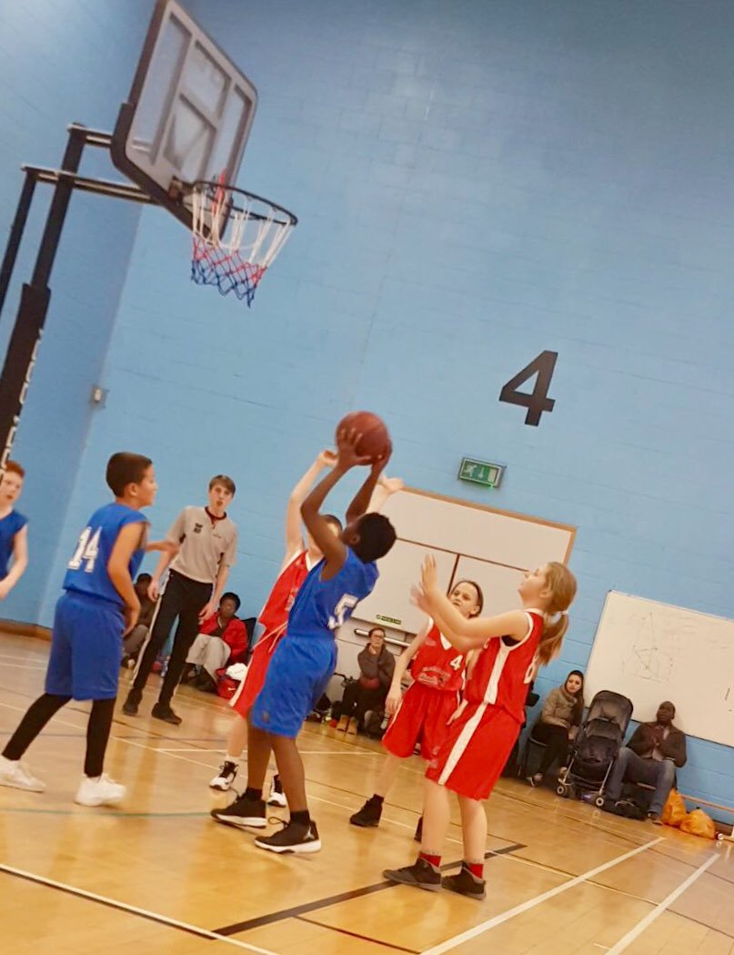
Activity: Basketball Festivals (Years 5 and 6) inside the main sports hall at Mark Hall Sports Centre
– November 2022

Spectators are discouraged from attending this event due to lack of space and safeguarding issues as requested by MHA.

Significant hazards / risks
- Insufficient planning for the task – user sustains injury, grazes, cuts or bruising;
- Person has collision with other user or other object (Basketball net/pole) due to poor supervision (and/or behaviour) or insufficient warning of activity - fracture, cuts, bruising;
- Issues relating to contact when playing (i.e. pushing off court into wall/net/bench etc.)

Who could be harmed?
- Persons undertaking and/or supervising/observing the activity
- Unauthorised user – (spectators; unlikely due to it being a closed event)

Competence Requirement:
Competence to supervise groups of children through;
- Experience of previous situations; use of clear instruction, main demonstration by SGO.
- Suitability for the task;
- On-going assessment whilst undertaking the activity and identify if further support may be required for activity;

Control measures which should be in place:
- Activities are properly planned and organised; this means, the task, the people responsible, competency, and pitch/floor conditions have all been considered before each event starts;
- Use of correct equipment for the task;
- Basketballs – good condition, not split
- Basketball posts – correct height (and additional weights to prevent tipping)
- First aid kits on hand (Gill Pardoe main first aid point) Defib inside the Sports Centre.
- Benches positioned to designate pitch and waiting areas; pitches (curtains) positioned to prevent the balls from passing onto the other court/pitch.
- Children will need to show understanding of safe use through actions. School staff
to monitor their teams / children and adapt as required.
- Monitoring; first aid equipment on site (carried by SGO) and additional first aid on site via Sports Centre’s main reception. SGO and school staff to access mobile phones and contact emergency services if required.

Additional Control Measures: Hints / tips for what needs to be considered as part of local /specific assessment:
- Make sure there’s space between courts and that additional balls are not accessible to non-playing teams to practise unsupervised with.
- Children need to wear suitable clothing and footwear.
- Bring labelled water bottle.
- School staff to be responsible for children’s toileting needs (these are located just outside the main hall inside the foyer) and general behaviour.

COMPLETE THIS SECTION LOCALLY
Establishment / Team: School Games Organiser (Harlow)

Assessed by (print): David Stacey |  |  |  | Date: September 2022
Local Assessment (Refer to Hints and Tips for guidance)

Date reviewed: | 27.09.22
Initials: | DS

