Generic Risk Assessment
Badminton Festival at Mark Hall Academy Sports Centre (indoors)
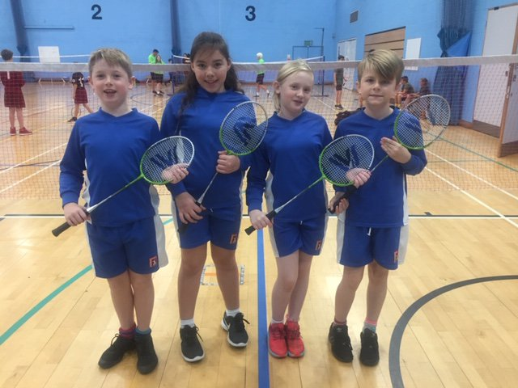
Activity: Badminton ‘Come and Try’ Festival
– September 2022

Spectators are discouraged from attending this event due to lack of space and safeguarding issues as requested by MHA

Significant hazards / risks
- Insufficient planning for the task – user sustains injury, grazes, cuts or bruising;
- Person has collision with equipment namely rackets and/or user or other object due to poor supervision (and/or behaviour) or insufficient warning of activity - fracture, cuts, bruising;

Who could be harmed?
- Persons undertaking and/or supervising the activity
- Unauthorised user – (note on this occasion, spectators are not permitted inside hall due to lack of space – large entry of teams)

Competence Requirement:
Competence to supervise groups of children through;
- experience of previous situations; use of clear instruction, demonstration
- suitability for the task;
- on-going assessment whilst undertaking the activity and identify if further support may be required for activity;

Control measures which should be in place:
- Activity is properly planned and organised; this means, the task, the people responsible, competency, and hall conditions have all been considered before each task starts;
- Use of correct equipment for the task;
- Shuttlecocks, Badminton rackets, designated waiting areas with benches and/or cones
- Competent instruction about safe use has been given (and adhered too) prior to activity starting. Children will need to show understanding of safe use through actions. School staff to monitor their teams / children and adapt as required.
- Monitoring; First aid kits on hand (Gill Pardoe main first aid point). Defibrillator inside the Sports Centre.
- SGO and school staff to access mobile phones and contact emergency services if required.

Additional Control Measures: Hints / tips for what needs to be considered as part of local /specific assessment:
- Children need to wear suitable clothing and footwear.
- School staff to be responsible for children’s toileting needs and general behaviour.
- Bring labelled water bottle.
- School staff to be responsible for children’s toileting needs (these are located just outside the main hall inside the foyer) and general behaviour.

COMPLETE THIS SECTION LOCALLY
Establishment / Team: School Games Organiser (Harlow)

Assessed by (print): David Stacey |  |  |  | Date: 22nd September 2022
Local Assessment (Refer to Hints and Tips for guidance)

Date reviewed: | DS
Initials: | 22.09.22

